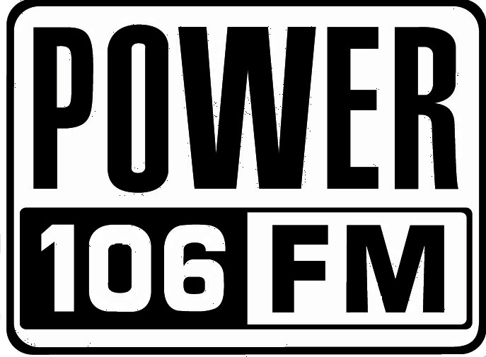
November 1, 2011

For Immediate Release:
Dianna Jason
2600 West Olive
Suite 850
Burbank, CA 91505
818-953-4200
djason@power106.com

POWER 106’s Cali Christmas 2011
DRAKE – J. COLE – BIG SEAN!

Friday, December 16, 2011 at Gibson Amphitheatre

POWER 106’s (KPWR, 105.9 Los Angeles) annual hip hop holiday concert is scheduled for Friday, December 16, 2011 at the Gibson Amphitheatre in Universal City, CA.

Headlining the show is hip hop superstar, DRAKE along with this year’s #1 selling recording artist J. Cole and Detroit’s Big Sean with his smash single and #1 watched video “My Last”. Opening the show will be the Bay area’s “Love Rance” with the hit single, “Up”, Audio Push, YG and the Chi-Town Breakers dance crew.

Power 106’s exclusive presale is Thursday, November 3 from 10:00am to 10:00pm. To access the presale password, go to http://.power106.com. Public on-sale is scheduled for Friday, November 4, 2011 at 10am. Tickets are available for purchase at http://.livenation.com and www.power106.com .

For complete Cali Christmas information, visit http://.power106.com.

Power 106 is owned and operated by Emmis Communications, a publicly traded company on NASDAQ (EMMS).

####

