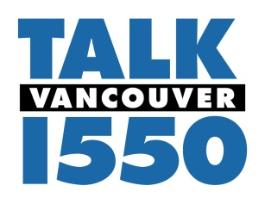
Contact: Dennis Glasgow
(503) 552-3324

August 30, 2011

AM 1550 KKOV adds College and High School Sports

Vancouver, WA – Pamplin Broadcasting’s AM 1550, Vancouver’s Talk Station has added an outstanding local sports compliment to its lineup that will include University of Washington Football and Greater St. Helens League High School Football.

Signing a 3-year agreement with IMG College, AM 1550 will broadcast all University of Washington Football games, including the Pre/Post Game Shows. Continuing its commitment to “local” programming for the Vancouver/Clark County region, AM 1550 will air a package of 16 Greater St. Helen’s League High School Football games over 9 weeks on Friday nights with long-time Vancouver Play-by-play Announcer Ron Soanka. The games will consist mostly of Double-header games for 3A and 4A High Schools. All games will be played and aired from McKenzie Stadium at Evergreen High School in Vancouver, Washington.

Dennis Glasgow, KPAM/KKOV Program Director said, “This is our continuing promise to the Southwest Washington listener that we’re committed to local programming that is most important to them. We’re acutely aware of Husky Nation and their insatiable thirst for Husky Sports, and we’re here to meet their demands. Airing University of Washington Sports and GSHL Football is a no-brainer for AM 1550 and we’re grateful for the opportunity to bring quality College and Amateur sports on Vancouver’s only Talk Station.”

The first games to be heard this season on AM 1550 will be this Friday at 7pm with the GSHL opener of Evergreen vs. Mt. View at 7pm. And the Washington Huskies opener will air this Saturday vs. Eastern Washington, kickoff at 4pm, pregame at 2pm. Complete schedules for both GSHL and Huskies Football can be viewed at 1550talk.com

Pamplin Broadcasting owned AM 1550 KKOV and www.1550talk.com is a conservative talk station with 50,000/12,000 watts in Vancouver, Washington and is home to SRN Programs that include; Bill Bennett, Mike Gallagher, Dennis Prager, Michael Medved, and Hugh Hewitt. AM 1550 is also home for Michael Savage, Doug Urbanski , Jim Bohannon and Neal Boortz - along with syndicated programming from Premiere, Westwood One, Radio America, United Stations and Dial-Global.

___________________________________

