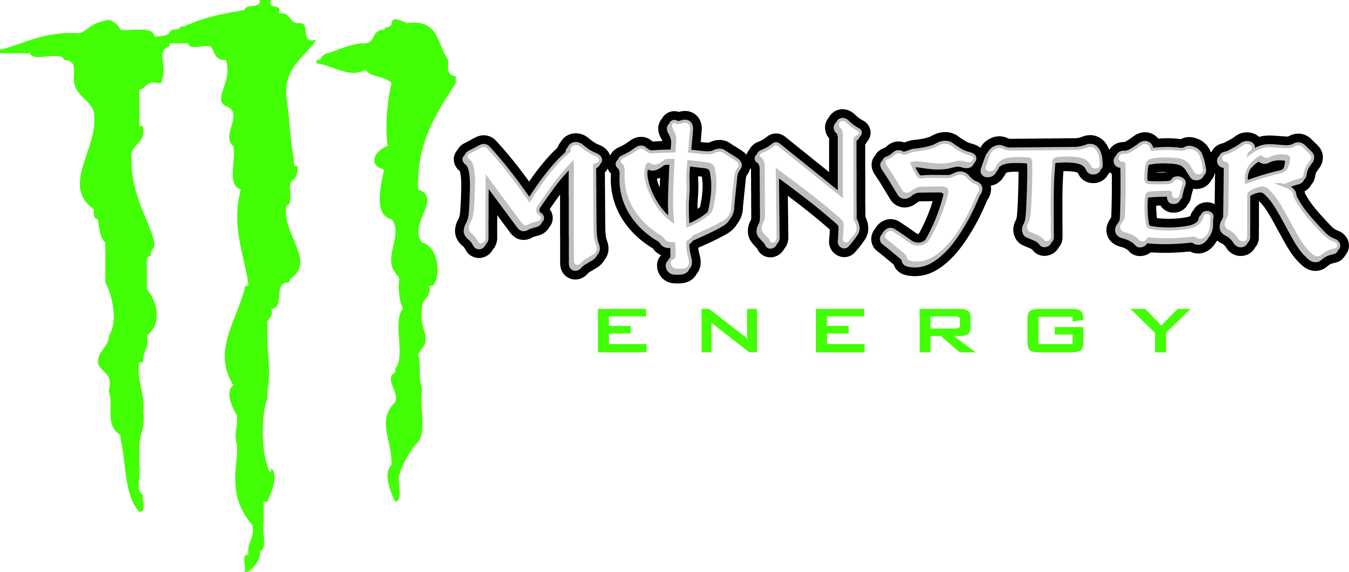
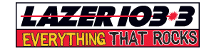
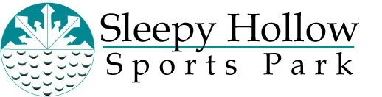

Press Release

For Immediate Release Contact: Rob Lembke
Thursday, January 20, 2011 Promotions Director
(515) 280-1350
rlembke@desmoinesradiogroup.com

Daredevils Ready for “Downhill Derby” Saturday
LAZER’s Morning Moose Throws Snow Challenge to Listeners

Des Moines, IA – The snow will fly and butts will bounce as LAZER’s “Morning Moose Downhill Derby” rockets the slopes of Sleep Hollow Sports Park this Saturday, January 22nd. Over 60 competitors have already opted-in to face down the slicked up course in a quest to take home some rockin’ prizes. Pre-registration is online now at www.lazer1033.com until noon Friday.

Lazer 103.3’s “Morning Moose Downhill Derby” is presented by Monster Energy Drinks and it’s as ‘simple’ as putting together a sled with only - cardboard, paint and duct tape. Some sleds will be like rockets, others will fall apart on descent – but everyone will have a blast as they reach for the kind of rewards LAZER listeners love:
- The fastest sled wins a $500 Visa Check Card courtesy of Landshark Promotion Studio.
- The most creative sled wins tickets to see Linkin Park at the Sprint Center in Kansas City on January 29th and will meet the band courtesy of Warner Brothers Records.
- Wear a crazy hat to the race and you could win tickets to see Rev theory when the play People’s Court in February!
Moose, B-Sox, and Amy Sweet from “Morning Moose” will be the hosts as mayhem ensues. Moose is pumped, “I can’t wait to check out all the creative rides LAZER listeners will come up with.” B-Sox gave a deep chuckle, “Yea and how their rides go, I tried it and I have bruises all over, you can check it out on the LAZER Facebook page.” http://www.facebook.com/lazer1033
Lazer 103.3’s “Morning Moose Downhill Derby” will happen at Sleepy Hallow Sports Park, 4051 Dean Avenue, Des Moines. Check-in Saturday is at 10 a.m. and the action is underway at 11:30 a.m. (You must be 18 or older to race.)

The Des Moines Radio Group consists of four FM and two AM stations in Des Moines: 93.3, KIOA; STAR 102.5, KSTZ; LAZER 103.3, KAZR; LITE 104.1, KLTI; PRAISE 940, KPSZ; and AM 1350, KRNT. Des Moines Radio Group is a division of Saga Communications, Inc. of Grosse Point Farms, Michigan. For more information, visit www.desmoinesradiogroup.com.
# # #

