NEWS RELEASE

Media Contact:

Suzi Hanks

Suzi.Hanks@coxmg.com

(713) 963-1200

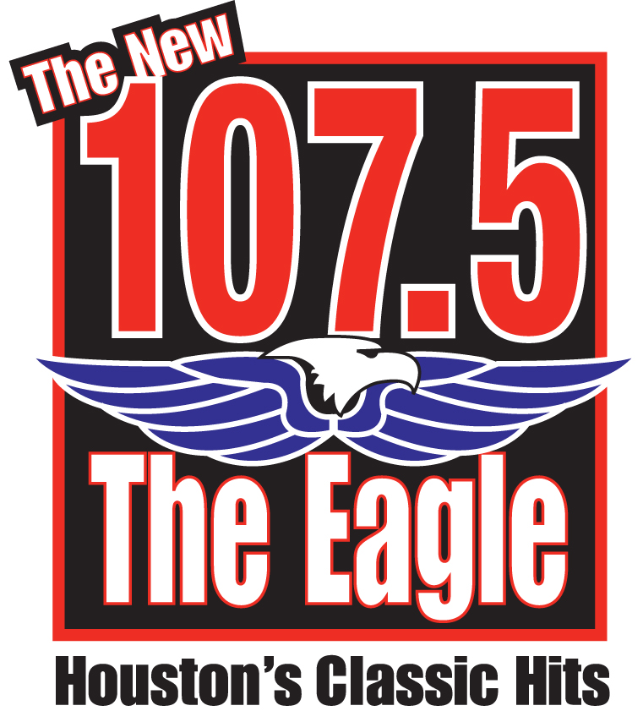

107.5 The Eagle’s Dean and Rog offer $50,000 to NFL players Andre Johnson and Cortland Finnegan for Brawl Rematch.

HOUSTON– Nov. 8, 2010 – Dean and Rog, morning show hosts for 107.5 The Eagle, are offering Houston Texans Andre Johnson, and Tennessee Titans’ Courtland Finnegan, a chance to finish their fight….for charity.

Radio Station 107.5 The Eagle, along with Dean and Rog, will contribute $50 grand (the total amount of their fines from the NFL) to a charity of their choice, if Johnson and Finnegan agree to a rematch of their fight during last weeks game.

Johnson and Finnegan were involved in a brutal fistfight that got both players ejected in the fourth quarter. Both drew fines of $25 thousand dollars each from the National Football League. The two had been pushing and jawing earlier in the game. Last season, Johnson was fined $7,500 for taking Finnegan to the ground by the facemask during a scuffle after a play in a 34-31 Texans win.

Rog Beaty, 107.5 The Eagle sports director and half of the Dean and Rog Morning Show, says a rematch would be an “Epic Super Fight, the likes of the Super Bowl, with knockdowns instead of touchdowns, and a stare down instead of a coin toss.” Dean Myers, Morning show co-host says “… to me, the fight would be like a ballet, except with no music, no choreography, and the dancers hit each other.”

About Cox Media Group
Cox Media Group, Inc., a subsidiary of Atlanta-based Cox Enterprises, is an integrated broadcasting, publishing and digital media company that includes the national advertising rep firms of Cox Reps. With revenues exceeding $1.5 billion, the company operations include 15 broadcast television stations and one local cable channel, 86 radio stations, four metro newspapers and more than a dozen non-daily publications, and more than 100 digital services. Additionally, CMG owns and operates Valpak, one of the leading direct marketing companies in North America.
###

